**Cluster Centers**

The code used in creating cluster centers is given below:

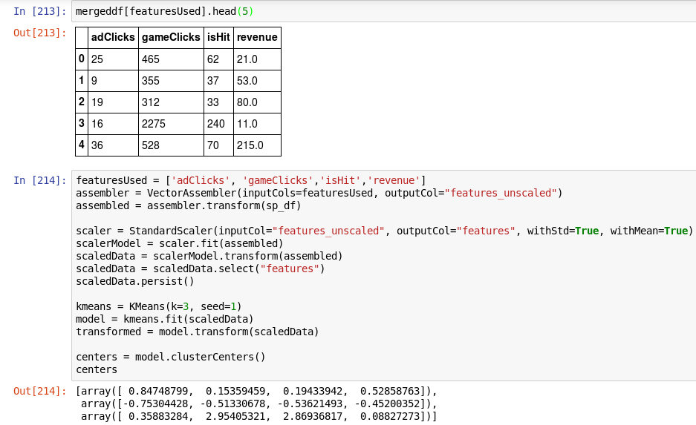

Cluster centers formed are given in the table below

|  |  |
| --- | --- |
| **Cluster #** | **Center**  **[**adClicks, gameClicks, isHit, revenue**]** |
| 1 | [ 0.84748799, 0.15359459, 0.19433942, 0.52858763] |
| 2 | [-0.75304428, -0.51330678, -0.53621493, -0.45200352] |
| 3 | [ 0.35883284, 2.95405321, 2.86936817, 0.08827273] |

**Attribute** - Represents

**adClicks** – ad engagement of user

**gameClicks** – game engagement of user

**isHit** – Skill of user

**revenue** – profit of game by user

These clusters can be differentiated from each other as follows:

**Cluster 1** is different from the others in that **users with the highest revenue** and adclick are **not the ones who have most game engagement** **but an intermediate (less Skilled) result** in game clicks.

**Cluster 2** is different from the others in that the users who **play the less** also **produces the less ad revenue** and click count

**Cluster 3** is different from the others in that the users with **average revenue although they play the most but as they have good result (high skill)**, the revenue in the middle along with the ad click count

Below you can see the summary of the train data set:

